Test Case: tc003_SPX_Dev5_Crear_Requisicion_Spot_Tipo_Cobro_CC_Urgent
Step 1 - Enter username and password and click to button Enter : Credentials Entered
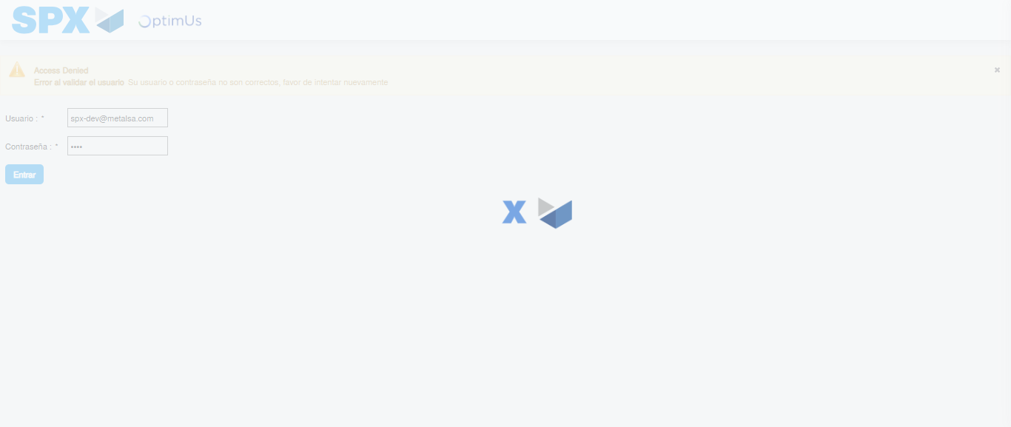Image file-name: QC_Testing-tc003_SPX_Dev5_Crear_Requisicion_Spot_Tipo_Cobro_CC_Urgent-1783358771383

Step 2 - Select to UEN and Access to Spot Buy Requisitions : UEN Correctly selected and Correct access
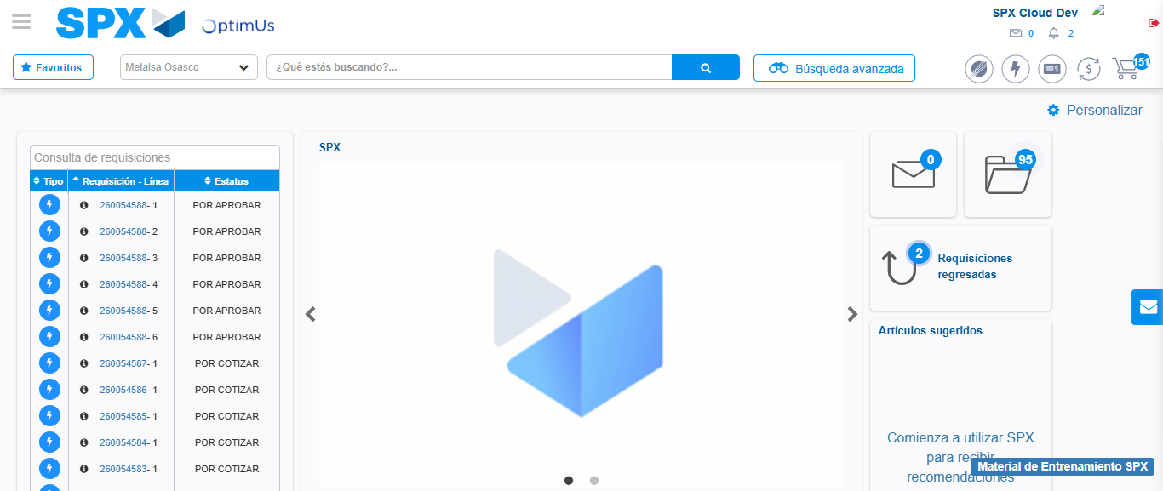Image file-name: QC_Testing-tc003_SPX_Dev5_Crear_Requisicion_Spot_Tipo_Cobro_CC_Urgent-1783358798568

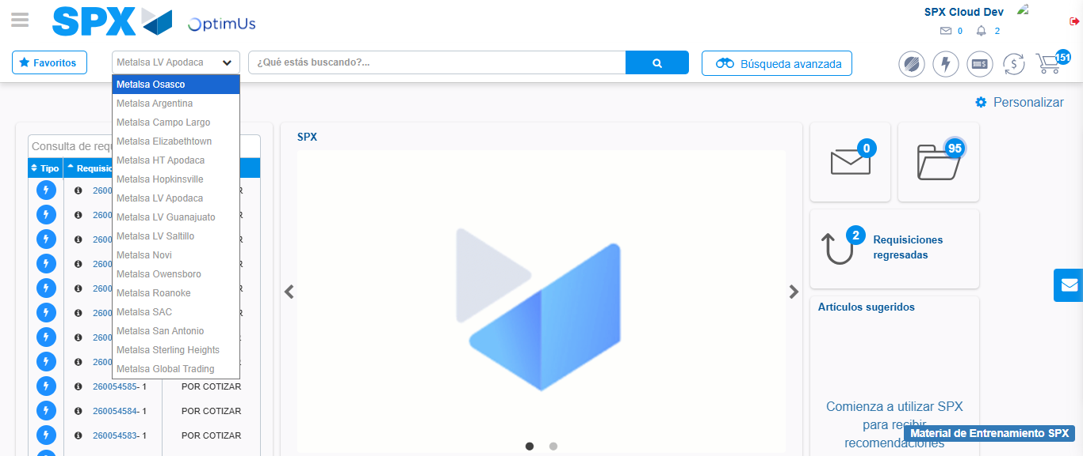Image file-name: QC_Testing-tc003_SPX_Dev5_Crear_Requisicion_Spot_Tipo_Cobro_CC_Urgent-1783358801290

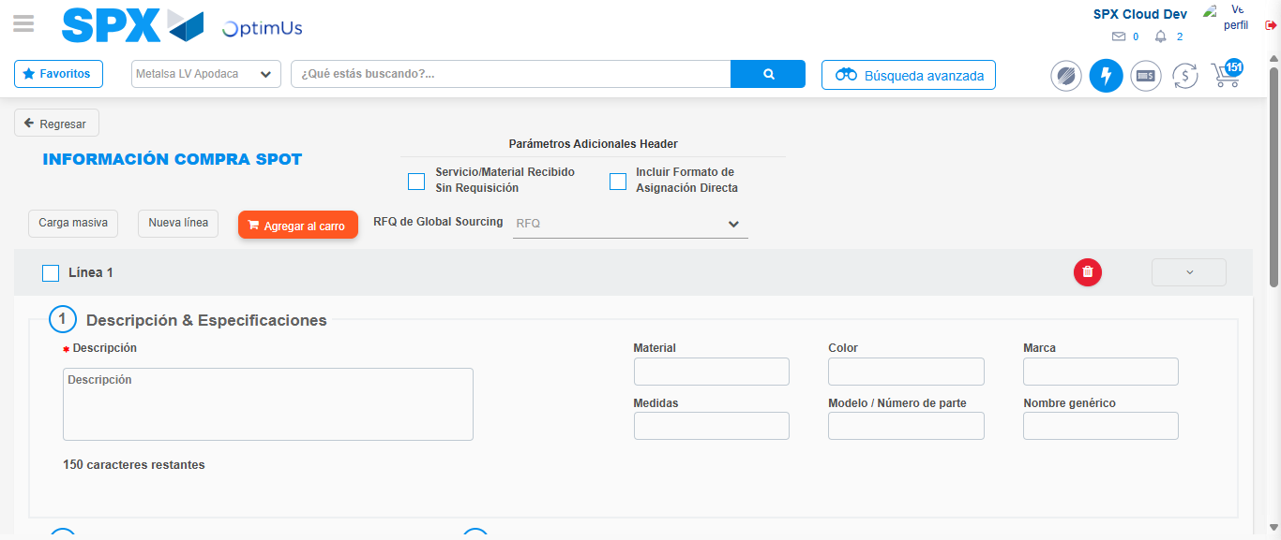Image file-name: QC_Testing-tc003_SPX_Dev5_Crear_Requisicion_Spot_Tipo_Cobro_CC_Urgent-1783358819618

Step 3 - Data Capture Spot Buy Requisition: Data captured correctly
Image file-name: QC_Testing-tc003_SPX_Dev5_Crear_Requisicion_Spot_Tipo_Cobro_CC_Urgent-1783358819911

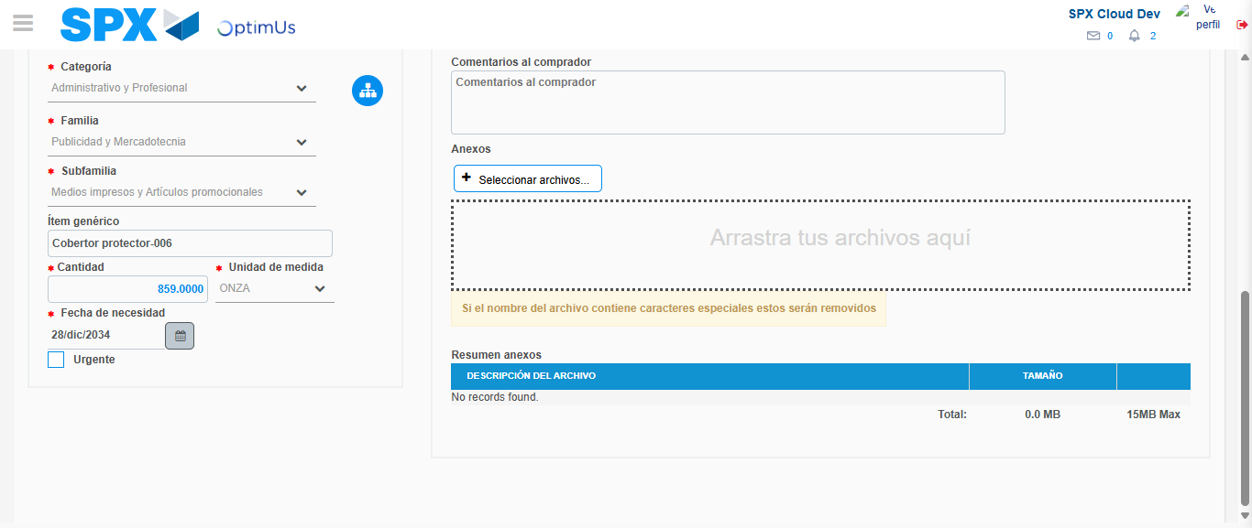Image file-name: QC_Testing-tc003_SPX_Dev5_Crear_Requisicion_Spot_Tipo_Cobro_CC_Urgent-1783358830440

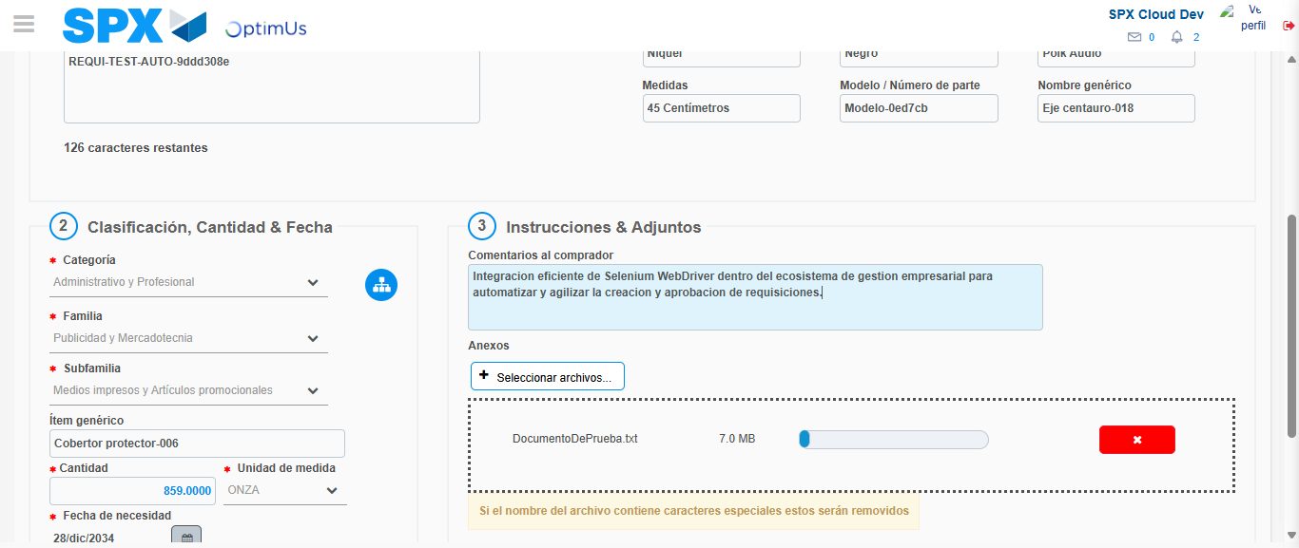Image file-name: QC_Testing-tc003_SPX_Dev5_Crear_Requisicion_Spot_Tipo_Cobro_CC_Urgent-1783358831435

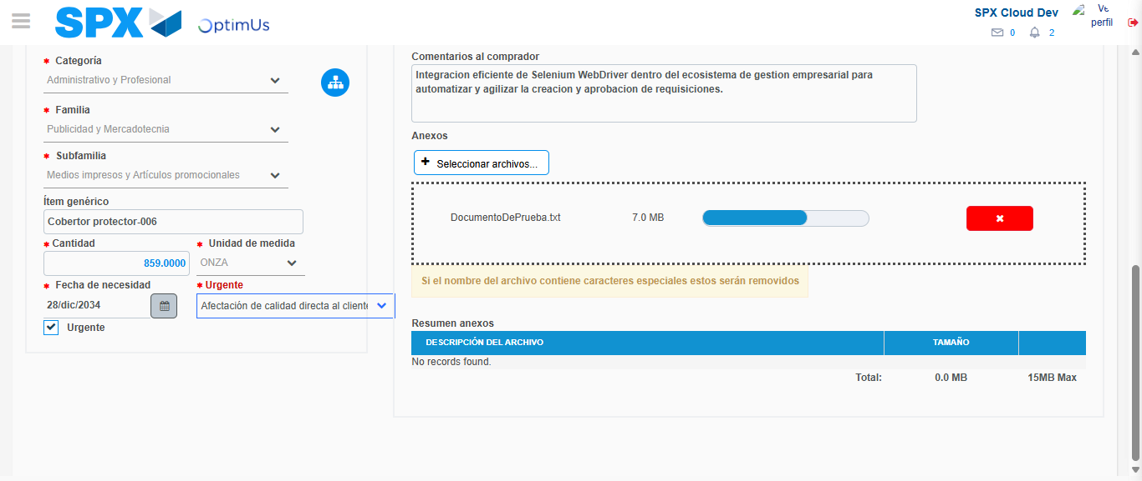Image file-name: QC_Testing-tc003_SPX_Dev5_Crear_Requisicion_Spot_Tipo_Cobro_CC_Urgent-1783358835270

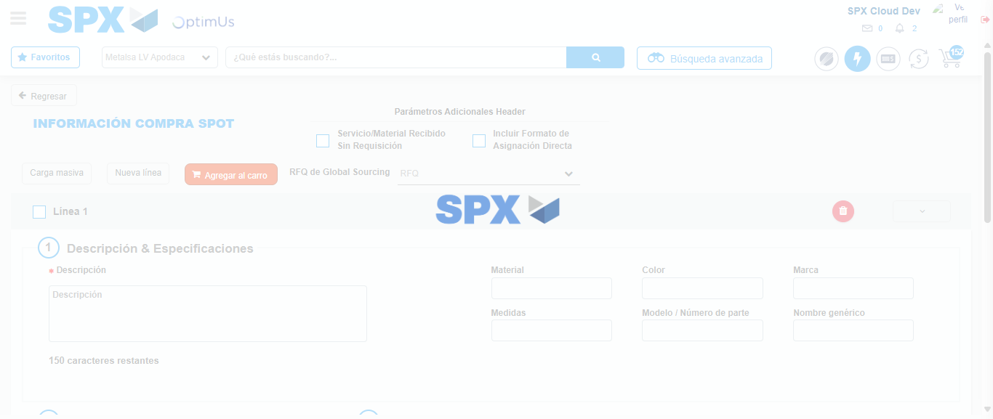Image file-name: QC_Testing-tc003_SPX_Dev5_Crear_Requisicion_Spot_Tipo_Cobro_CC_Urgent-1783358844551

Step 7 - Return to Main Page SPX : Return to Main Page SPX
Image file-name: QC_Testing-tc003_SPX_Dev5_Crear_Requisicion_Spot_Tipo_Cobro_CC_Urgent-1783358798568

Image file-name: QC_Testing-tc003_SPX_Dev5_Crear_Requisicion_Spot_Tipo_Cobro_CC_Urgent-1783358801290

Image file-name: QC_Testing-tc003_SPX_Dev5_Crear_Requisicion_Spot_Tipo_Cobro_CC_Urgent-1783358819618

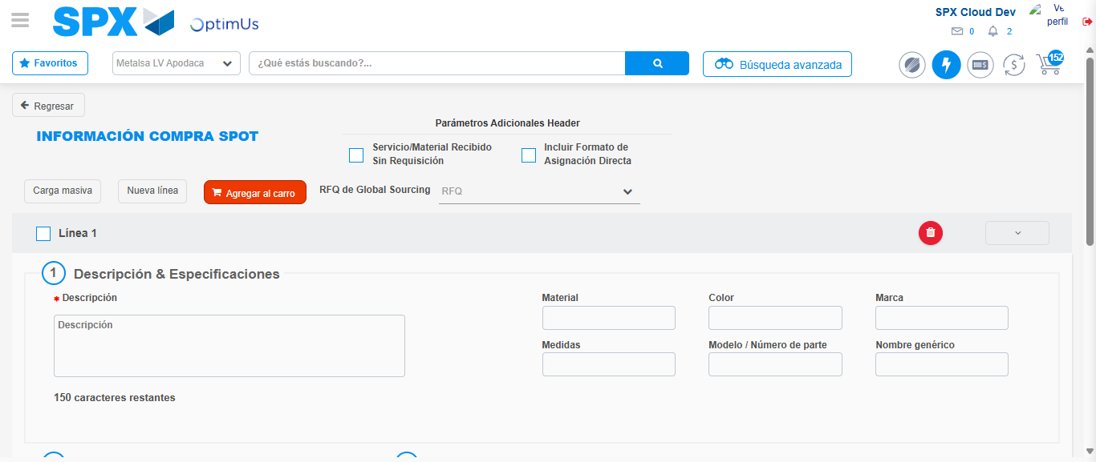Image file-name: QC_Testing-tc003_SPX_Dev5_Crear_Requisicion_Spot_Tipo_Cobro_CC_Urgent-1783358846830

Image file-name: QC_Testing-tc003_SPX_Dev5_Crear_Requisicion_Spot_Tipo_Cobro_CC_Urgent-1783358847041

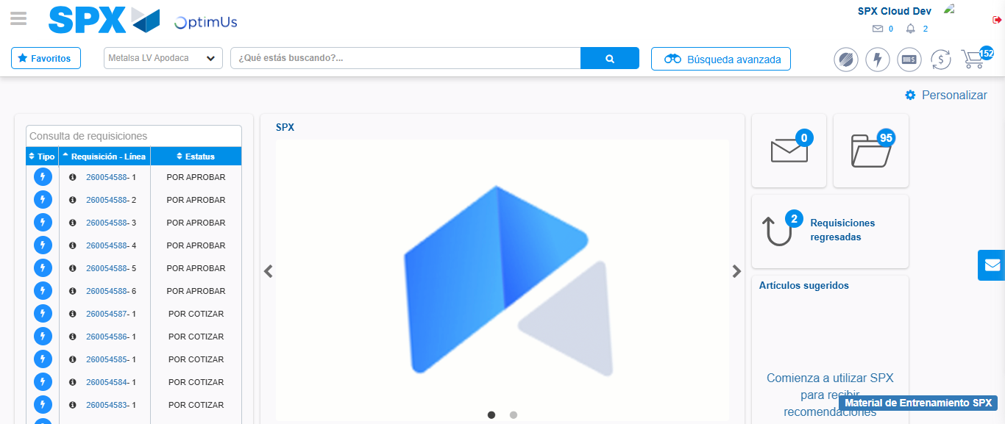Image file-name: QC_Testing-tc003_SPX_Dev5_Crear_Requisicion_Spot_Tipo_Cobro_CC_Urgent-1783358868517

Step 8 - Log Out : Log Out SPX
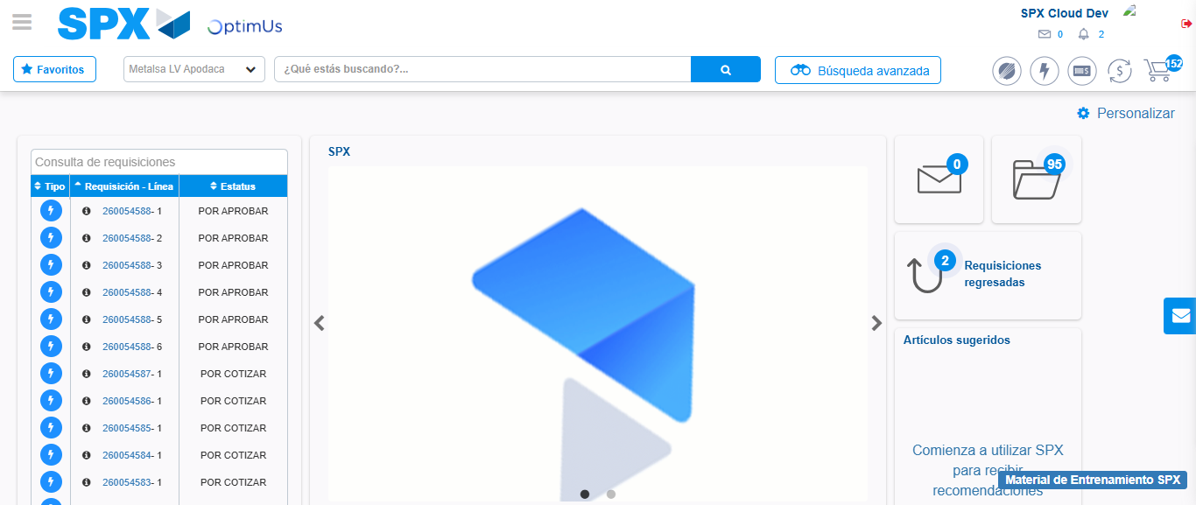Image file-name: QC_Testing-tc003_SPX_Dev5_Crear_Requisicion_Spot_Tipo_Cobro_CC_Urgent-1783358868906

